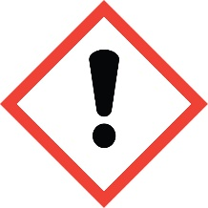
FESTIVE HOME – 20%
Warning: May cause an allergic skin reaction. Harmful to aquatic life
with long lasting effect. Harmful to aquatic life with long lasting effects
IF ON SKIN: Wash with plenty of soap and water. If skin irritation or
rash occurs: Get medical advice/attention. Dispose of contents/container
to approved disposal site, in accordance with local regulations. Contains-
CINNAMAL, LIMONENE, METHYLCINNAMIC ALDEHYDE,
OCTAHYDROCOUMARIN. CITRAL, COUMARIN, EUGENOL.
MANUFACTURER- Your Business name, your full
Business address &, contact telephonel number

