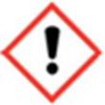
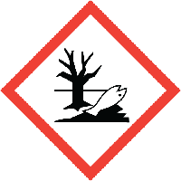
FRAGRANCE – BORA BORA
20% with Augeo

Warning: May cause an allergic skin reaction. Causes serious eye irritation,
Toxic to aquatic life with long lasting effects. IF IN EYES: Rinse cautiously
with water for several minutes. Remove contact lenses, if present and easy to do.
Continue rinsing. IF ON SKIN: Wash with plenty of soap and water.
If skin irritation or rash occurs: Get medical advice/attention.
Dispose of contents/container to approved disposal site, in accordance
with local regulations. Contains-,2-dimethyl-1,3-dioxolan-4-ylmethanol
ALLYLCYCLOHEXYLPROPIONATE, ISOPROPYLIDENEGLYCEROL, LIMONENE, LINALOOL
ALLYL ALPHA-IONONE, ETHYL 3-PHENYLGLYCIDATE, GERANIOL.
May produce an allergic reaction
MANUFACTURER – Your business name, 12 Any Street, Anywhere,
Your County, AA12BB. Your telephone number 01234568910

