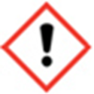
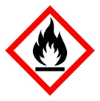
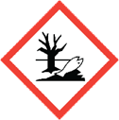
FRAGRANCE – BLACK POMEGRANATE
20% in Perfumers Alcohol

DANGER - Keep away from heat, hot surfaces, sparks, open flames and other ignition sources. No smoking
WARNING: May cause an allergic skin reaction. Causes serious eye irritation,
Toxic to aquatic life with long lasting effects. IF IN EYES: Rinse cautiously
with water for several minutes. Remove contact lenses, if present and easy to do.
Continue rinsing. IF ON SKIN: Wash with plenty of soap and water.
If skin irritation or rash occurs: Get medical advice/attention.
Dispose of contents/container to approved disposal site, in accordance
with local regulations. Contains- ALCOHOL, EUGENOL, HYDROXYISOHEXYL 3-CYCLOHEXENE CARBOXALDEHYDE, TETRAMETHYL ACETYLOCTAHY-
DRONAPHTHALENES (E)-1-(2,6,6-TRIMETHYL-1,3-CYCLOHEXADIEN-1-YL)-2-BUTEN-1-
ONE, DIHYDRO PENTAMETHYLINDANONE (DPMI). May produce an allergic reaction
MANUFACTURER – Your business name, 12 Any Street, Anywhere,
Your County, AA12BB. Your telephone number 01234568910

