FRAGRANCE – Fairy Dust (@20%)
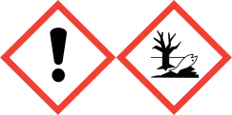
Warning: May cause an allergic skin reaction. Toxic to aquatic life
with long lasting effects. Avoid breathing vapour or dust.
IF ON SKIN: Wash with plenty of soap and water. If skin
irritation or rash occurs: Get medical advice/attention.
Collect spillage. Dispose of contents/container to approved disposal
site, in accordance with local regulations. Contains, - ALPHAISOMETHYL
IONONE, HYDROXYISOHEXYL 3-CYCLOHEXENE CARBOXALDEHYDE,
TETRAMETHYL ACETYLOCTAHYDRONAPHTHALENES BUTYLPHENYL
METHYLPROPIONAL, CITRONELLOL, GERANYL ACETATE.
May produce an allergic reaction.
MANUFACTURER – Your business name, 12 Any Street, Anywhere,
Your County, AA12BB. Your telephone number 01234568910

