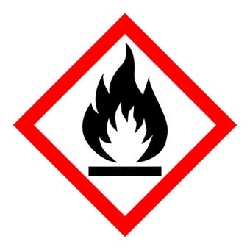
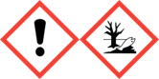
FRAGRANCE – FAIRY DUST
20% in Perfumers Alcohol

DANGER - Keep away from heat, hot surfaces, sparks, open flames and other ignition sources. No smoking
Warning: May cause an allergic skin reaction. Causes serious eye
irritation. Toxic to aquatic life with long lasting effects. Avoid breathing
vapour or dust. IF ON SKIN: Wash with plenty
of soap and water. IF IN EYES: Rinse cautiously with water for
several minutes. Remove contact lenses, if present and easy to do.
Continue rinsing. If skin irritation or rash occurs: Get medical
advice/attention. Collect spillage. Dispose of contents/container to
approved disposal site, in accordance with local regulations. Contains
ALCOHOL, ALPHA-ISOMETHYL IONONE, TETRAHYDRO-METHYL-(METHYLPROPYL)
-PYRAN-4-OL, TETRAMETHYL ACETYLOCTAHYDRONAPHTHALENES
CITRONELLOL, GERANYL ACETATE, NERYL ACETATE. May produce an allergic reaction. MANUFACTURER – Your business name, 12 Any Street, Anywhere,
Your County, AA12BB. Your telephone number 01234568910

