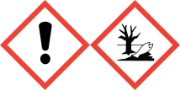
FRAGRANCE – Blonde Moment (UK)
10%

Warning: May cause an allergic skin reaction. Toxic to
aquatic life with long lasting effects. IF ON SKIN: Wash
with plenty of soap and water. If skin irritation or rash occurs:
Get medical advice/attention. Dispose of contents/container
to approved disposal site, in accordance with local regulations.
Contains DLIMONENE, DELTA-DAMASCONE, BETA-PINENES,
HEXYL CINNAMAL . May produce an allergic reaction.
MANUFACTURER – Your business name, 12 Any Street, Anywhere,
Your County, AA12BB. Your telephone number 01234568910

